Ministerul Educaţiei, Tineretului şi Sportului al Republicii Moldova Universitatea Tehnică a Moldovei

Facultatea Calculatoare, Informatică şi Microelectronică Departamentul Informatica si Ingineriia Sistemelor

RAPORT

Lucrare de laborator nr.2

# la Analiza şi Sinteza Dispozitivelor Numerice

# V-10

A efectuat: st. gr.

Popa Catalin

A verificat: asist.univ.

A. Ursu

*Chişinău 2021*

Lucrare de laborator nr.2

**Tema:** Sinteza convertoarelor de cod

# Alcătuiți tabela de adevăr pentru funcțiile logice

𝑦1 ș𝑖 𝑦2.

# Minimizați funcțiile 𝑦1 ș𝑖 𝑦2 .

* Determinati elementele commune,

# Inlocuiti elementele commune,

1. Creati circuitul convertorului de cod in LogicWorks .

# Determinati costul(C) si reinerea de timp(rT).

Codul binar-zecimal intrare: 8 5 -2 -4

Codul binar-zecimal ieşire: 4 3 1 1

# Convertorul binar-zecimal:

|  |  |  |  |  |  |  |  |  |  |
| --- | --- | --- | --- | --- | --- | --- | --- | --- | --- |
|  | 8 | 5 | -2 | (-4) |  | 4 | 3 | 1 | 1 |
| 𝑥1 | 𝑥2 | 𝑥3 | 𝑥4 | 𝑦1 | 𝑦2 | 𝑦3 | 𝑦4 |
| 0 | 0 | 0 | 0 | 0 | 0 | 0 | 0 | 0 |
| 1 | 0 | 1 | 0 | 1 | 0 | 0 | 0 | 1 |
| 2 | 1 | 0 | 1 | 1 | 0 | 0 | 1 | 1 |
| 3 | 1 | 1 | 0 | 0 | 0 | 1 | 0 | 0 |
| 4 | 1 | 0 | 0 | 1 | 0 | 1 | 0 | 1 |
| 5 | 0 | 1 | 0 | 0 | 1 | 0 | 1 | 0 |
| 6 | 1 | 0 | 1 | 0 | 1 | 0 | 1 | 1 |
| 7 | 1 | 1 | 1 | 1 | 1 | 1 | 0 | 0 |
| 8 | 1 | 0 | 0 | 0 | 1 | 1 | 1 | 0 |
| 9 | 1 | 1 | 0 | 1 | 1 | 1 | 1 | 1 |
|  | 0 | 0 | 0 | 1 | * | * | * | * |
| 0 | 0 | 1 | 0 | * | * | * | * |
| 0 | 0 | 1 | 1 | * | * | * | * |
| 0 | 1 | 1 | 0 | * | * | * | * |
| 0 | 1 | 1 | 1 | * | * | * | * |
| 1 | 1 | 1 | 0 | * | * | * | * |

**Minimizarea functiilor:**

**Y1**

|  |  |  |  |  |
| --- | --- | --- | --- | --- |
| X1x2  X3x4 | **00** | **01** | **11** | **10** |
| **00** |  | **1** |  | **1** |
| **01** | **\*** |  | **1** |  |
| **11** | **\*** | **\*** | **1** |  |
| **10** | **\*** | **\*** | **\*** | **1** |

**y1 = x1x2x4 + x1x2x4 + x1x2x4**

**Y2**

|  |  |  |  |  |
| --- | --- | --- | --- | --- |
| X1x2  X3x4 | **00** | **01** | **11** | **10** |
| **00** |  |  | **1** | **1** |
| **01** | **\*** |  | **1** | **1** |
| **11** | **\*** | **\*** | **1** |  |
| **10** | **\*** | **\*** | **\*** |  |

**y2= x1x3 + x1x2**

**Y3**

|  |  |  |  |  |
| --- | --- | --- | --- | --- |
| X1x2  X3x4 | **00** | **01** | **11** | **10** |
| **00** |  | **1** |  | **1** |
| **01** | **\*** |  | **1** |  |
| **11** | **\*** | **\*** |  | **1** |
| **10** | **\*** | **\*** | **\*** | **1** |

**y3 = x1x2x4 + x1x2x4 + x1x2x3x4 + x2x3**

**Y4**

|  |  |  |  |  |
| --- | --- | --- | --- | --- |
| X1x2  X3x4 | **00** | **01** | **11** | **10** |
| **00** |  |  |  |  |
| **01** | **\*** | **1** | **1** | **1** |
| **11** | **\*** | **\*** |  | **1** |
| **10** | **\*** | **\*** | **\*** | **1** |

**y4 = x3x4 + x2x3**

y1 = x1x2x4 + x1x2x4 + x1x2x4

y2= x1x3 + x1x2

y3 = x1x2x4 + x1x2x4 + x1x2x3x4 + x2x3

y4 = x3x4 + x2x3

**Determinam x care se repeta:**

a = x1x2x4

b = x1x2x4

c = x2x3

**Inlocuim x:**

y1 = a + b + x1x2x4

y2= x1x3 + x1x2

y3 = b + a + x1x2x3x4 + c

y4 = x3x4 + c

**Circuitul convertorului de cod**

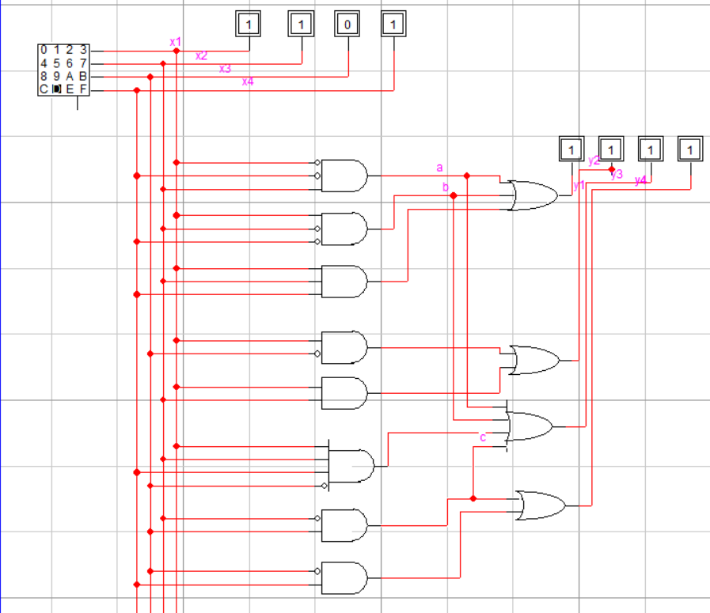

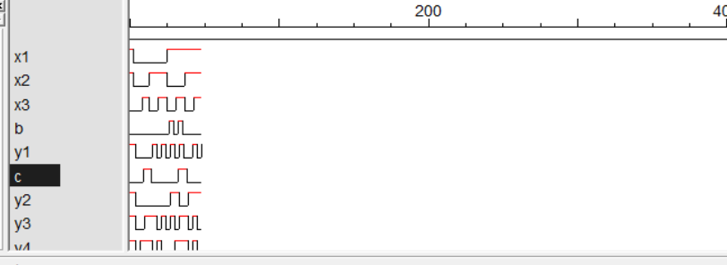

Costul: 2 Timpul:32